**CONNECT2HOSPITALS**

An Application Development Lab Report Submitted In partial fulfilment

of the requirements for the award of the degree of

# Bachelor of Technology

# in

# Computer Science and Engineering

## by

**Kaithi. Kranthi Kumar Reddy 20N31A0594**

**Kandrathi Avinash 21N35A0512**

**Edla. Sirish Preetham 21N35A0507**

Under the esteemed guidance of

## Mrs.T. Padmaja

### Assistant Professor



# Department of Computer Science and Engineering

**Malla Reddy College of Engineering & Technology**

(Autonomous Institution- UGC, Govt. of India)

(Affiliated to JNTUH, Hyderabad, Approved by AICTE, NBA &NAAC with ‘A’ Grade) Maisammaguda, Kompally, Dhulapally, Secunderabad – 500100 website: www.mrcet.ac.in

**2020-2024**



**Malla Reddy College of Engineering & Technology**

(Autonomous Institution- UGC, Govt. of India)

(Affiliated to JNTUH, Hyderabad, Approved by AICTE, NBA &NAAC with ‘A’ Grade) Maisammaguda, Kompally, Dhulapally, Secunderabad – 500100 website: www.mrcet.ac.in

# CERTIFICATE

This is to certify that this is the bonafide record of the project entitled “**Connect2Hospitals**”, submitted by Kaithi Kranthi Kumar Reddy (20N31A0594), Kandrathi Avinash (21N35A0512), Edla Sirish Preetham (21N35A0507) of B.Tech in the partial fulfilment of the requirements for the degree of Bachelor of Technology in Computer Science and Engineering, Department of CSE during the year 2022-2023. The results embodied in this project report have not been submitted to any other university or institute for the award of any degree or diploma.

**Internal Guide Head of the Department**

**Mrs.T.Padmaja Dr. S. Shanthi**

**Assistant Professor Professor**

**External Examiner**

**DECLARATION**

We hereby declare that the project titled “**Connect2Hospitals**” submitted to Malla Reddy College of Engineering and Technology (UGC Autonomous), affiliated to Jawaharlal Nehru Technological University Hyderabad (JNTUH) for the award of the degree of Bachelor of Technology in Computer Science and Engineering is a result of original research carried-out in this thesis. It is further declared that the project report or any part thereof has not been previously submitted to any University or Institute for the award of degree or diploma.

**Kaithi Kranthi Kumar Reddy - (20N31A0594)**

**Kandrathi Avinash - (21N35A0512)**

**Edla Sirish Preetham - (21N35A0507)**

**ACKNOWLEDGEMENT**

We would like to express my profound gratitude to Dr. S. Srinivas Rao, Principal of MallaReddy College Of Engineering & Technology, and Dr. S. Shanthi, HOD of CSE department for their contributions to the completion of my project Language Translator.

We would like to express my special thanks to our mentor Mrs. T. Padmaja for her time and efforts she provided throughout the year. Your useful advice and suggestions were really helpful to me during the project’s completion. In this aspect, I am eternally grateful to you.

With regards and gratitude

**Kaithi. Kranthi Kumar Reddy - (20N31A0594)**

**Kandrathi Avinash - (21N35A0512)**

**Edla. Sirish Preetham - (21N35A0507)**

## 

**ABSTRACT**

In a world where everything is digitalized and everyone is connected through the internet, most of the time-consuming tasks can be completed within the limited time. “**Connect2Hospitals**” is a web application that is used to connect patients with nearby medical staff and helps them get treatment. As the current world is engulfed by many dangerous diseases, the number of people who might be suffering from health issues is also increasing significantly. Even though some of these diseases can be treated, accessibility to healthcare is difficult. Long appointment wait times can have a negative impact on patient satisfaction and healthcare experience. To deal with such issues, this application helps the user i.e. patients to connect to nearby hospitals, then a medical staff with regarding your concern will come to your home. This in turn saves a lot of time and also if the patient is given treatment or at least first-aid in time. It helps reduce the chances of getting an infection needing longer medical care or getting the situation worse. If the treatment requires more attention, then they will be shifted to the hospital. This will mainly target the individual people who are living independently. This application is built using HTML, CSS, and JavaScript. Due to its simple user interface user can easily access the features of the application.

### 

### 

### 

|  |  |
| --- | --- |
| **TABLE OF CONTENTS**  **S.NO TITLE**       1. **INTRODUCTION**     1. PURPOSE, AIM AND OBJECTIVES    2. BACKGROUND OF PROJECT    3. MODULES DESCRIPTION 2. **SYSTEM ANALYSIS**     1. HARDWARE AND SOFTWARE REQUIREMENTS    2. SOFTWARE REQUIREMENTS SPECIFICATION 3. **TECHNOLOGIES USED**     1. HTML    2. CSS      1. **SYSTEM DESIGN & UML DIAGRAMS**     1. ARCHITECTURE    2. UNIFIED MODELING LANGUAGE      1. **IMPLEMENTATION**      1. **OUTPUT SCREENS** 2. **CONCLUSION**      1. **FUTURE SCOPE** | **PG.NO**  **09**  09  10  10  **11**  11  12  **13**  13  14    **15**  15  16    **20**  **25**  **28**    **29** |

**LIST OF FIGURES**

**FIG NO. NAME PG.NO**

|  |  |  |
| --- | --- | --- |
| **4.2** | SYSTEM  ARCHITECTURE  DIAGRAM | **15** |
| **4.3.2.1** | CLASS DIAGRAM | **17** |
| **4.3.2.2** | ACTIVITY DIAGRAM | **18** |
| **4.3.2.3** | USE CASE DIAGRAM | **19** |

|  |  |  |
| --- | --- | --- |
| **FIG NO.** | **NAME** | **PG.NO** |
| **6.1** | SIGN UP PAGE | **25** |
| **6.2** | HOME PAGE | **25** |
| **6.3** | SERVICES PAGE | **26** |
| **6.4** | HOSPITALS PAGE | **26** |
| **6.5** | DOCTORS PAGE | **27** |
| **6.6** | APPOINTMENT PAGE | **27** |

**List of OUTPUT Screens**

**1.** **INTRODUCTION**

### As the current world is engulfed by many dangerous diseases, the number of people who might be suffering from health issues is also increasing significantly. Even though some of these diseases can be treated, accessibility to healthcare is difficult. Long appointment wait times can have a negative impact on patient satisfaction and healthcare experience. To deal with such issues, this application helps the user i.e. patients to connect to nearby hospitals, then a medical staff with regarding your concern will come to your home. This in turn saves a lot of time and also if the patient is given treatment or at least first-aid in time. It helps reduce the chances of getting an infection needing longer medical care or getting the situation worse. If the treatment requires more attention, then they will be shifted to the hospital.

### 1.1 PURPOSE

**AIM & OBJECTIVES**

This study lays out a framework for a new system to be developed and brought to the market for maximum use and to create an avenue through the web where users can log on to our server and make a selection of whatever medical services they like and subsequently pay via the internet. The following are the objectives this would bring:

1. The home page of this web interfile provides an avenue where patients will be able to get the treatment within time at their own location.

2. The services offered would provide the patients with all the different categories of available services that they can choose and select from.

3. This will provide a user friendly environment between the patients and hospitals thus increasing the efficiency of the curing at their location.

4. There will also be the information about the medicine and the treatment if it can be done by themselves.

5. It will help all independent people of the world.

**1.2 BACKGROUND OF PROJECT**

In the ambulatory healthcare environment, use of Connect2Hospitals can improve the efficiency and health of a people. For years, many people are independent and also don’t want themselves to be depending on something when they are sick or emergency. The use Connect2Hospitals offers an opportunity to monitor and improve clinical quality and easy treatments at their locations by improving hospital access in the locality . In addition, the patients can also know about their health status after the consultation through website. The website gives all the information about the doctors those are present in the hospitals and what they are designated for treatment.

### 1.3 SCOPE OF THE PROJECT

The demand for hospital and healthcare management is increasing in India, mainly due to increasing medical tourism and India becoming a hub for medical tourism; some patients are visiting for treatment. Apart from this, health and hygiene awareness are also increasing; therefore, there is an increasing demand for hospital and healthcare management. As the demand increases, the scope and opportunities in this sector are also increasing. The management department plays a vital role in the healthcare sector because this is the segment where one needs to provide the best services and manage financial resources.

### 1.4 MODULES OF DESCRIPTION

#### PATIENT

Patient module deals with operations that a patient need to perform while using this application. When a patient need any treatment at their location then the patient should provide the information and book appointment to a doctor to their location. The patient should select the hospital, doctor and date of the appointment.

#### HOSPITAL OPERATOR

Hospital Operator module deals with the other side of the application which receives the information of the patient about their appointment with doctor name, date and address of the patient. The operator accepts the request of the patient and confirms the appointment when the doctor is available to make the treatment. After the treatment if any emergency the operator will send the ambulance and make admission in the same hospital.

#### 2. SYSTEM ANALYSIS

#### 2.1 HARDWARE &SOFTWARE REQUIREMENTS

**HARDWARE REQIREMENTS:**

* I3 Processor Based computer
* 1GB-RAM
* 5 GB Hard Disk
* 1 GB RAM

**SOFTWARE REQUIREMENTS:**

* Windows 7 or higher
* HTML
* CSS
* Visual Studio Code

**2.2 SOFTWARE REQUIREMENTS SPECIFICATION**

**2.2.1 SRS:**

Software Requirement Specification(SRS) is the starting point of the software developing activity. As system grew more complex it became evident that the goal of the entire system cannot be easily comprehended. Hence the need for the requirement phase arose. The software project is initiated by the client needs. The SRS is the means of translating the ideas of the minds of clients (the input) into a formal document (the output of the requirement phase.) The SRS phase consists of two basic activities:

1. **Problem/Requirement Analysis**:

The process is order and more nebulous of the two, deals with understand the problem, the goal and constraints.

1. **Requirement Specification:**

Here, the focus is on specifying what has been found giving analysis such as representation, specification languages and tools, and checking the specifications are addressed during this activity. The Requirement phase terminates with the production of the validate SRS document. Producing the SRS document is the basic goal of this phase.

**2.2.2 ROLE OF SRS:**

The purpose of the Software Requirement Specification is to reduce the communication gap between the clients and the developers. Software Requirement Specification is the medium through which the client and user needs are accurately specified. It forms the basis of software development. A good SRS should satisfy all the parties involved in the system.

**2.2.3 SCOPE:**

This document is the only one that describes the requirements of the system. It is meant for the use by the developers, and will also be the basis for validating the final delivered system. Any changes made to the requirements in the future will have to go through a formal change approval process. The developer is responsible for asking for clarifications, where necessary, and will not make any alterations without the permission of the client.

### 

### 3 TECHNOLOIGIES USED

#### 3.1 HTML:

The **Hypertext Markup Language** or **HTML** is the standard markup language for documents designed to be displayed in a web browser. It is often assisted by technologies such as Cascading Style Sheets (CSS) and scripting languages such as JavaScript.

Web browsers receive HTML documents from a web server or from local storage and render the documents into multimedia web pages. HTML describes the structure of a web page semantically and originally included cues for its appearance.

HTML elements are the building blocks of HTML pages. With HTML constructs, images and other objects such as interactive forms may be embedded into the rendered page. HTML provides a means to create structured documents by denoting structural semantics for text such as headings, paragraphs, lists, links, quotes, and other items. HTML elements are delineated by *tags*, written using angle brackets. Tags such as <**img** /> and <**input** /> directly introduce content into the page. Other tags such as <**p**> and </**p**> surround and provide information about document text and may include sub-element tags. Browsers do not display the HTML tags but use them to interpret the content of the page.

HTML can embed programs written in a scripting language such as JavaScript, which affects the behavior and content of web pages. The inclusion of CSS defines the look and layout of content. The World Wide Web Consortium (W3C), former maintainer of the HTML and current maintainer of the CSS standards, has encouraged the use of CSS over explicit presentational HTML since 1997. A form of HTML, known as HTML5, is used to display video and audio, primarily using  element, together with JavaScript.

#### 

#### 

### 

### 3.2 CSS:

**Cascading Style Sheets** (**CSS**) is a style sheet language used for describing the presentation of a document written in a markup language such as HTML or XML (including XML dialects such as SVG, MathML or XHTML). CSS is a cornerstone technology of the World Wide Web, alongside HTML and JavaScript.

CSS is designed to enable the separation of content and presentation, including layout, colors, and fonts. This separation can improve content accessibility; provide more flexibility and control in the specification of presentation characteristics; enable multiple web pages to share formatting by specifying the relevant CSS in a separate .css file, which reduces complexity and repetition in the structural content; and enable the .css file to be cached to improve the page load speed between the pages that share the file and its formatting.

Separation of formatting and content also makes it feasible to present the same markup page in different styles for different rendering methods, such as on-screen, in print, by voice (via speech-based browser or screen reader), and on Braille-based tactile devices. CSS also has rules for alternate formatting if the content is accessed on a mobile device.

The name cascading comes from the specified priority scheme to determine which style rule applies if more than one rule matches a particular element. This cascading priority scheme is predictable.

The CSS specifications are maintained by the World Wide Web Consortium (W3C). Internet media type (MIME type) text/css is registered for use with CSS by RFC 2318 (March 1998). The W3C operates a free CSS validation service for CSS documents.

In addition to HTML, other markup languages support the use of CSS including XHTML, plain XML, SVG, and XUL.

**4 . SYSTEM DESGIN & UML DIAGRAMS**

#### 4.1 SOFTWARE DESGIN

In designing the software following principles are followed:

1. **Modularity and partitioning**: Software is designed such that, each system should consists of hierarchy of modules and serve to partition into separate function.
2. **Coupling**: Modules should have little dependence on other modules of a system.
3. **Cohesion**: Modules should carry out in a single processing function.
4. **Shared use**: Avoid duplication by allowing a single module be called by other that need the function it provides.

#### 4.2 ARCHITECTURE

Architecture diagram is a diagram of a system, in which the principal parts or functions are represented by blocks connected by lines that show the relationships of the blocks. The block diagram is typically used for a higher level, less detailed description aimed more at understanding the overall concepts and less at understanding the details of implementation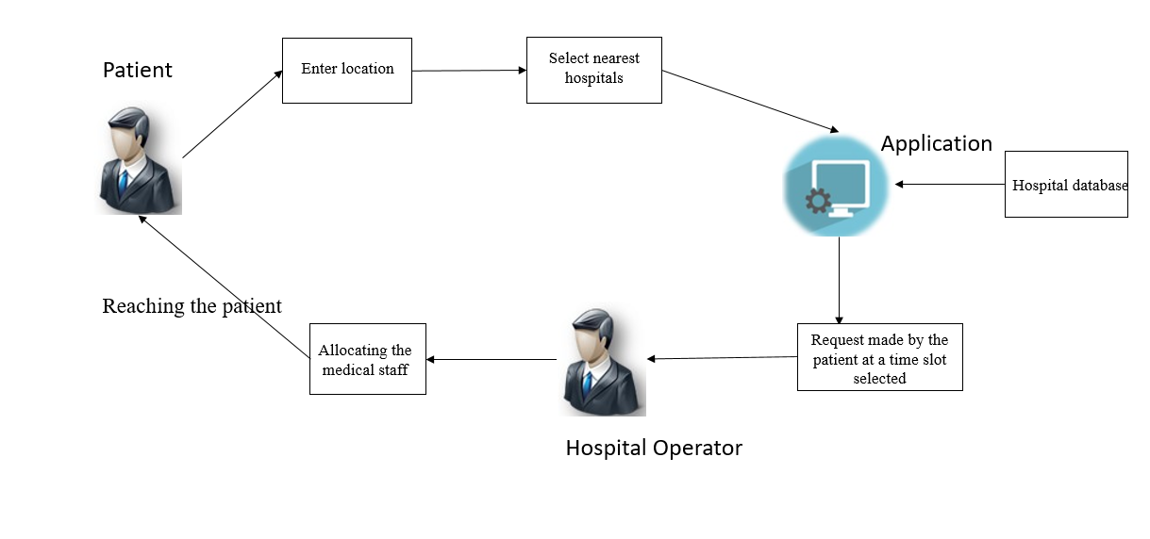 **Fig4.2.Software architecture**

**4.3 UNIFIED MODELING LANGUAGE (UML):**

The unified modelling is a standard language for specifying, visualizing, constructing and documenting the system and its components is a graphical language which provides a vocabulary and set of semantics and rules. The UML focuses on the conceptual and physical representation of the system. It captures the decisions and understandings about systems that must be constructed. It is used to understand, design, configure and control information about the systems.

Depending on the development culture, some of these artifacts are treated more or less formally than others. Such artifacts are not only the deliverables of a project; they are also critical in controlling, measuring, and communicating about a system during its development and after its deployment.

The UML focuses on the conceptual and physical representation of the system. It captures the decisions and understandings about systems that must be constructed. It is used to understand, design, configure and control information about the systems.

Some of these artifacts are treated more or less formally than others. Such artifacts are not only the deliverables of a project; they are also critical in controlling, measuring, and communicating about a system during its development and after its deployment.

Interaction diagrams are a subclass of behavioural diagrams that give emphasis to object interactions and also depicts the flow between various use case elements of a system. In simple words, it shows how objects interact with each other and how the data flows within them. It consists of communication, interaction overview, sequence, and timing diagrams.

**4.3.1 UML DIAGRAMS**

**CLASS DIAGRAM**

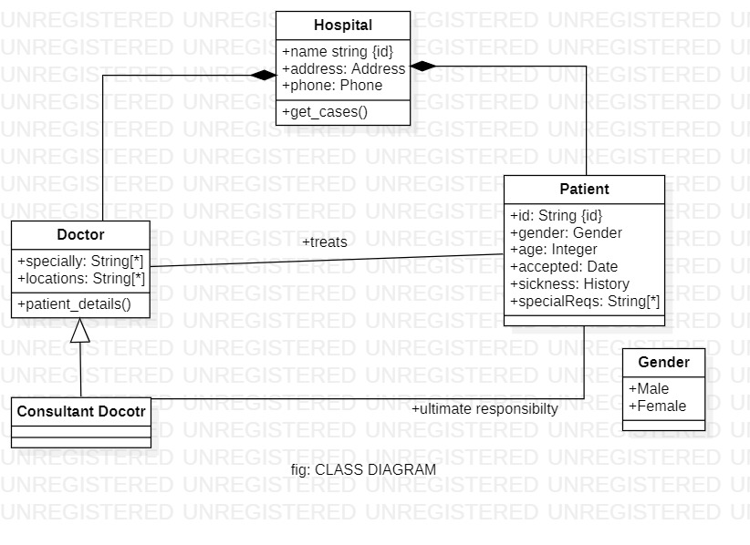

###### Fig4.3.2.1: class diagram

**Activity Diagram**

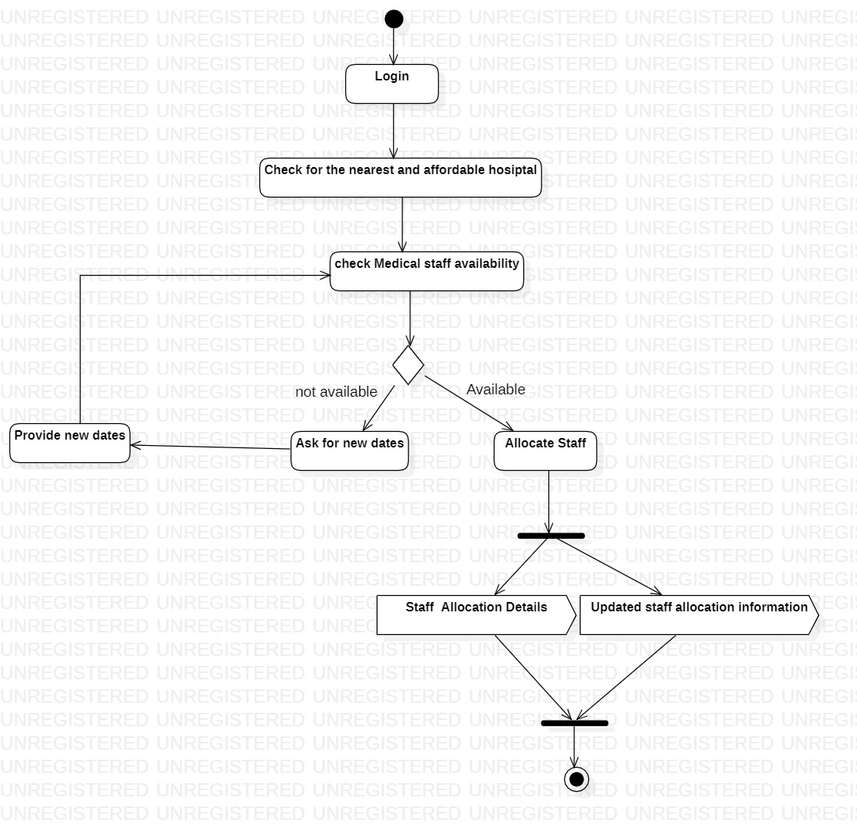

###### Fig4.3.2.2: Activity diagram

**USE CASE DIAGRAM**

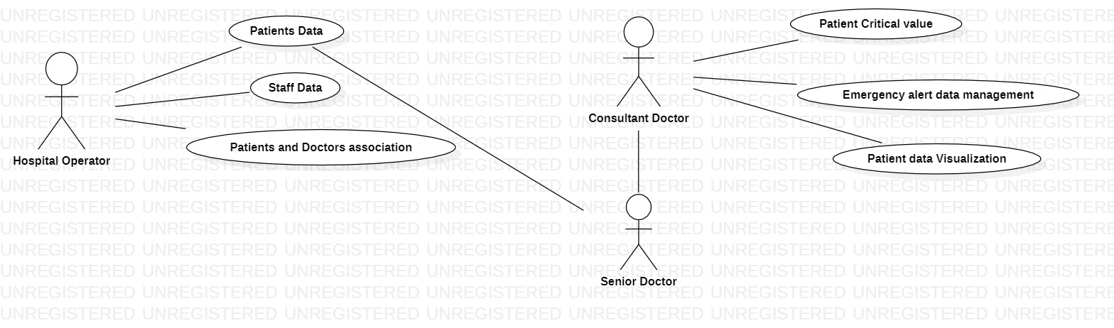

**Fig4.3.2.3: Use Case diagram**

### A use case diagram is used to represent the dynamic behaviour of a system. It encapsulates the system's functionality by incorporating use cases, actors, and their relationships. It models the tasks, services, and functions required by a system/subsystem of an application. It depicts the high-level functionality of a system and also tells how the user handles a system.

It is essential to analyze the whole system before starting with drawing a use case diagram, and then the system's functionalities are found. And once every single functionality is identified, they are then transformed into the use cases to be used in the use case diagram.

Once both the actors and use cases are enlisted, the relation between the actor and use case/ system is inspected. It identifies the no of times an actor communicates with the system. Basically, an actor can interact multiple times with a use case or system at a particular instance of time.

**5. IMPLEMENTATION**

<!DOCTYPE html>

<html>

<head>

<title>Home</title>

<style>

a

{

text-decoration:none;

}

</style>

</head>

<body>

<table style="width:100%">

<tr>

<td colspan="2"><img src="images/logo.png"></td>

</tr>

<tr style="background:#0cb8b6;">

<td align="center" style="padding:10px;"><a href="index.html" style="color:#fff;">Home</a></td>

<td align="center" style="padding:10px;"><a href="about.html" style="color:#fff;">About</a></td>

<td align="center" style="padding:10px;"><a href="services.html" style="color:#fff;">Services</a></td>

<td align="center" style="padding:10px;"><a href="doctors.html" style="color:#fff;">Doctors</a></td>

<td align="center" style="padding:10px;"><a href="appointment.html" style="color:#fff;">Appointment</a></td>

<td align="center" style="padding:10px;"><a href="faq.html" style="color:#fff;">Faq</a></td>

<td align="center" style="padding:10px;"><a href="testimonials.html" style="color:#fff;">Testimonials</a></td>

<td align="center" style="padding:10px;"><a href="contact.html" style="color:#fff;">Contact</a></td>

</tr>

<tr>

<td colspan="8"><img src="images/banner.avif" style="width:100%;"></td>

</tr>

<tr>

<td colspan="4" style="padding:20px;">

<h1>About Us</h1>

<p>

Health care is the improvement of health via the prevention, diagnosis, treatment, amelioration or cure of disease, illness, injury, and other physical and mental impairments in people. Health care is delivered by health professionals and allied health fields. Medicine, dentistry, pharmacy, midwifery, nursing, optometry, audiology, psychology, occupational therapy, physical therapy, athletic training, and other health professions all constitute health care. It includes work done in providing primary care, secondary care, and tertiary care, as well as in public health.</p>

<p>

Access to health care may vary across countries, communities, and individuals, influenced by social and economic conditions as well as health policies. Providing health care services means "the timely use of personal health services to achieve the best possible health outcomes".[3] Factors to consider in terms of health care access include financial limitations (such as insurance coverage), geographical and logistical barriers (such as additional transportation costs and the possibility to take paid time off work to use such services), sociocultural expectations, and personal limitations (lack of ability to communicate with health care providers, poor health literacy, low income).[4] Limitations to health care services affects negatively the use of medical services, the efficacy of treatments, and overall outcome (well-being, mortality rates).

</p>

</td>

<td colspan="4" style="padding:20px;">

<img src="images/about.jpg" style="width:100%;">

</td>

</tr>

<tr>

<td colspan="8" style="padding:5px 20px;">

<h2>Our Services</h2>

</td>

</tr>

<tr>

<td colspan="2" style="padding:20px;">

<img src="images/serv1.jpg" style="width:330px; height:300px;">

<p>For your child whitest teeths</p>

<h4>DENTIST</h4>

</td>

<td colspan="2" style="padding:20px;">

<img src="images/serv2.jpg" style="width:330px; height:300px;">

<p>Got a broken heart?</p>

<h4>CARDIOLOGIST</h4>

</td>

<td colspan="2" style="padding:20px;">

<img src="images/serv3.jpg" style="width:330px; height:300px;">

<p>Neck or back pain?</p>

<h4>CHIROPRACTOR</h4>

</td>

<td colspan="2" style="padding:20px;">

<img src="images/serv4.jpg" style="width:330px; height:300px;">

<p>Oral problems?</p>

<h4>PEDIATRICIAN</h4>

</td>

</tr>

<tr>

<td colspan="8" style="padding:5px 20px;">

<h2>Our Doctors</h2>

</td>

</tr>

<tr>

<td colspan="2" style="padding:20px;">

<img src="images/doc1.jpg" style="width:330px; height:300px;">

<p>Pediatrician</p>

<h4>Sussie Wolff</h4>

</td>

<td colspan="2" style="padding:20px;">

<img src="images/doc2.jpg" style="width:330px; height:300px;">

<p>Dental surgeon</p>

<h4>Ashley Willson</h4>

</td>

<td colspan="2" style="padding:20px;">

<img src="images/doc3.jpg" style="width:330px; height:300px;">

<p>Cosmetic Surgeon</p>

<h4>Gabriela Beckett</h4>

</td>

<td colspan="2" style="padding:20px;">

<img src="images/doc4.jpg" style="width:330px; height:300px;">

<p>General Doctor</p>

<h4>George Button</h4>

</td>

</tr>

</table>

</body>

</html>

<!DOCTYPE html>

<html>

<head>

<title>Contact</title>

<style>

a

{

text-decoration:none;

}

</style>

</head>

<body>

<table style="width:100%">

<tr>

<td colspan="2"><img src="images/logo.png"></td>

</tr>

<tr style="background:#0cb8b6;">

<td align="center" style="padding:10px;"><a href="index.html" style="color:#fff;">Home</a></td>

<td align="center" style="padding:10px;"><a href="about.html" style="color:#fff;">About</a></td>

<td align="center" style="padding:10px;"><a href="services.html" style="color:#fff;">Services</a></td>

<td align="center" style="padding:10px;"><a href="doctors.html" style="color:#fff;">Doctors</a></td>

<td align="center" style="padding:10px;"><a href="appointment.html" style="color:#fff;">Appointment</a></td>

<td align="center" style="padding:10px;"><a href="faq.html" style="color:#fff;">Faq</a></td>

<td align="center" style="padding:10px;"><a href="testimonials.html" style="color:#fff;">Testimonials</a></td>

<td align="center" style="padding:10px;"><a href="contact.html" style="color:#fff;">Contact</a></td>

</tr>

<tr>

<td colspan="8"><img src="images/banner.avif" style="width:100%;"></td>

</tr>

<tr>

<td colspan='8' style="padding:20px;">

<h1>Contact Us</h1>

<form>

<label>Name</label><br/>

<input type="text"><br/>

<label>Email</label><br/>

<input type="email"><br/>

<label>Mobile</label><br/>

<input type="text"><br/>

<label>Message</label><br/>

<textarea></textarea><br/>

<input type="submit">

</form>

</td>

</tr>

<tr style="background:#0cb8b6;">

<td colspan="8" align="center" style="padding:10px;">

</td>

</tr>

</table>

</body>

</html>

**6 . OUTPUT SCREENS**

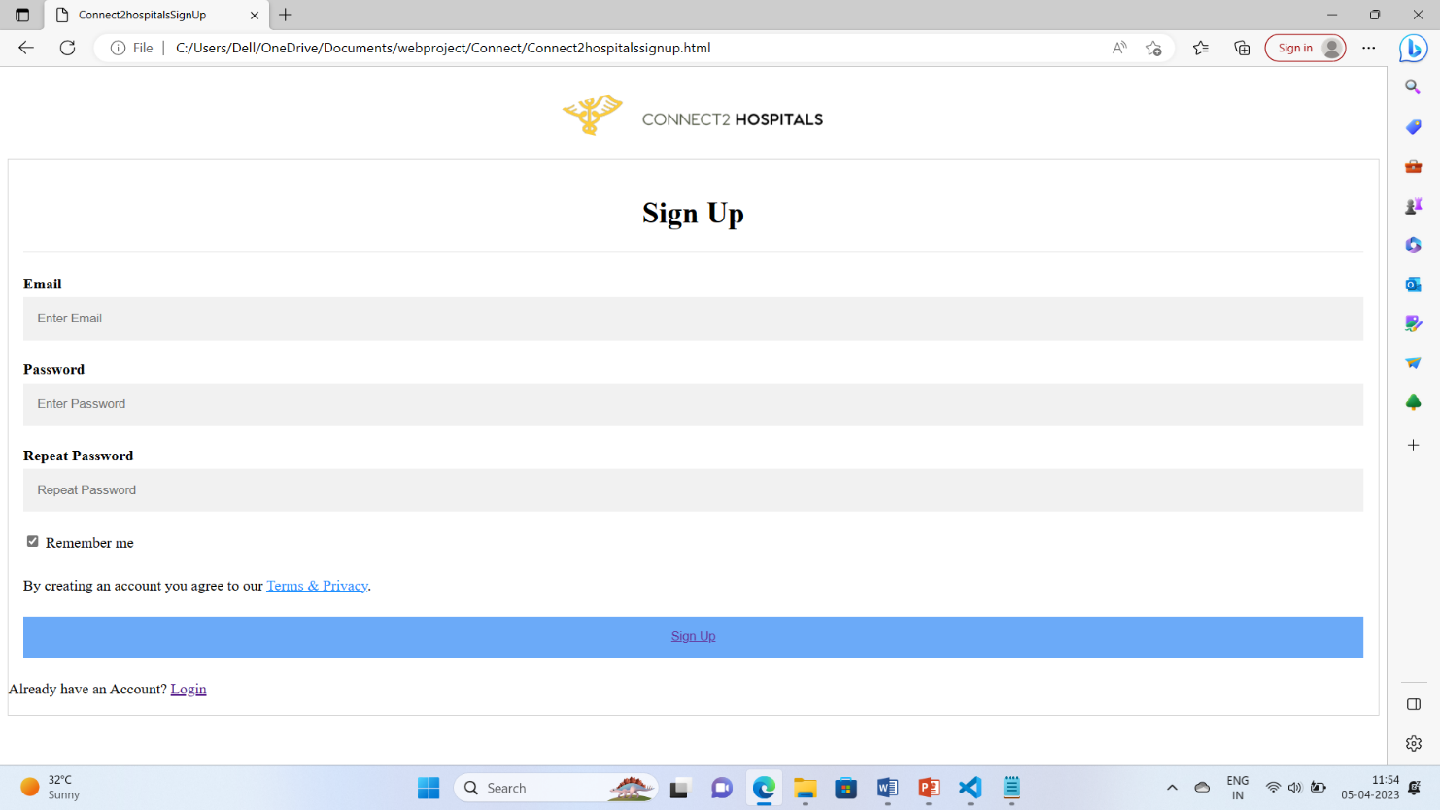

**Fig 6.1 Signup Page**

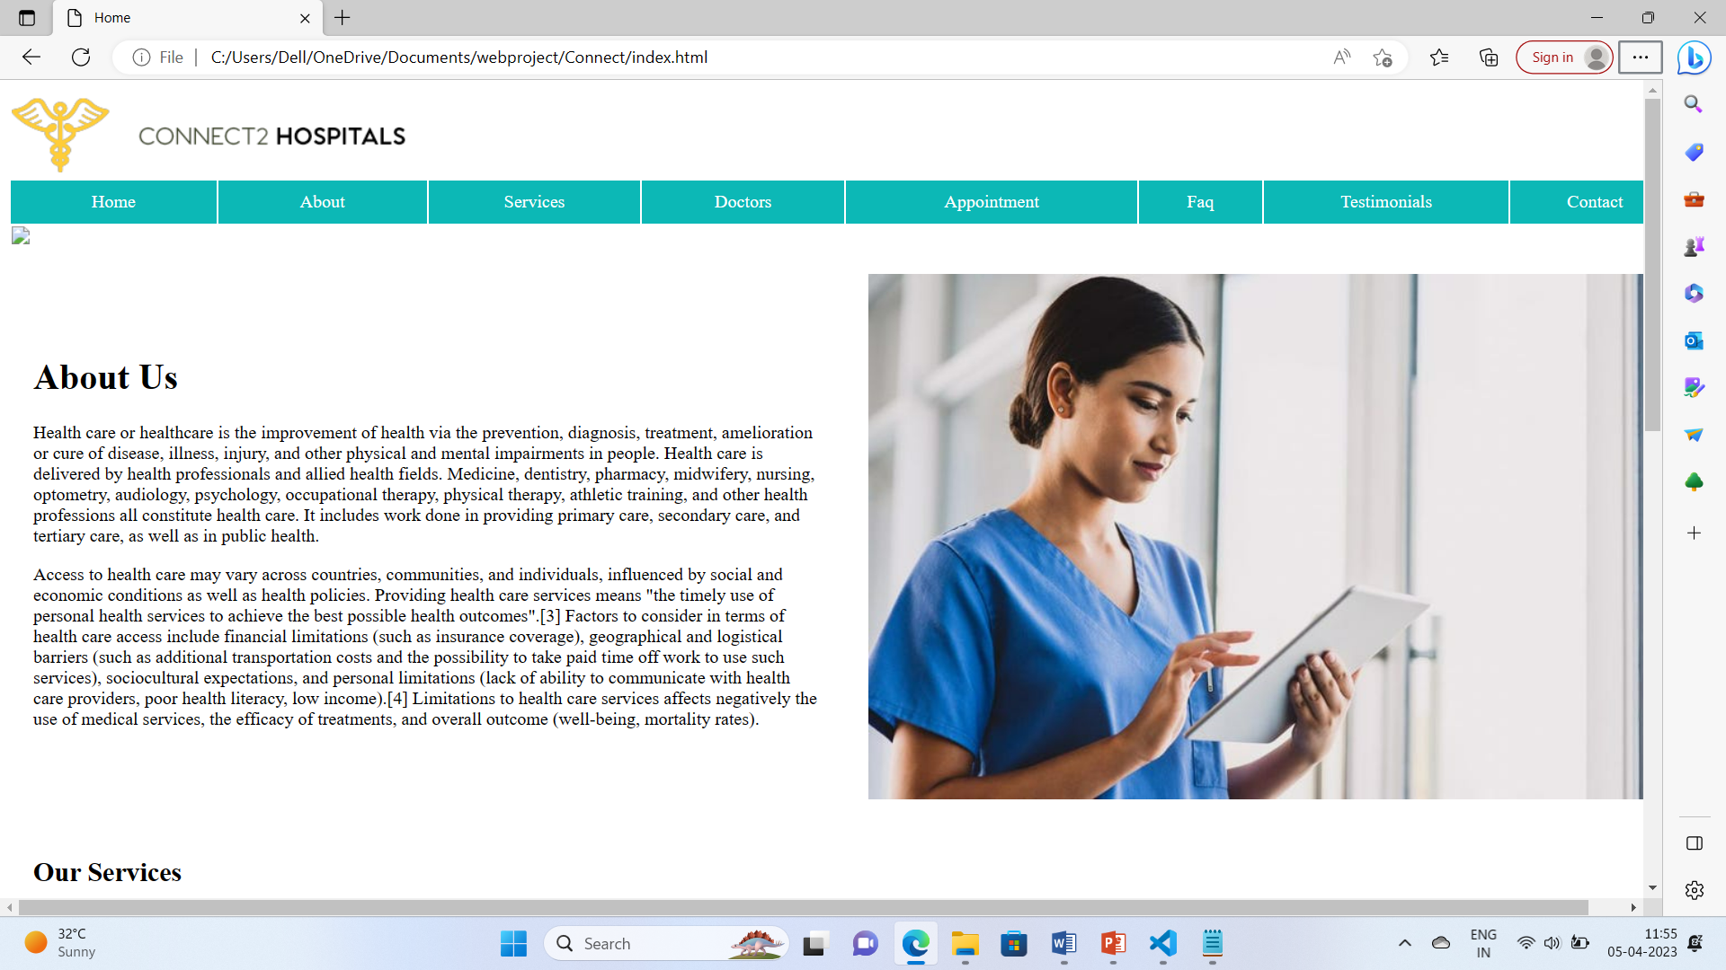

**Fig 6.2 Home Page**

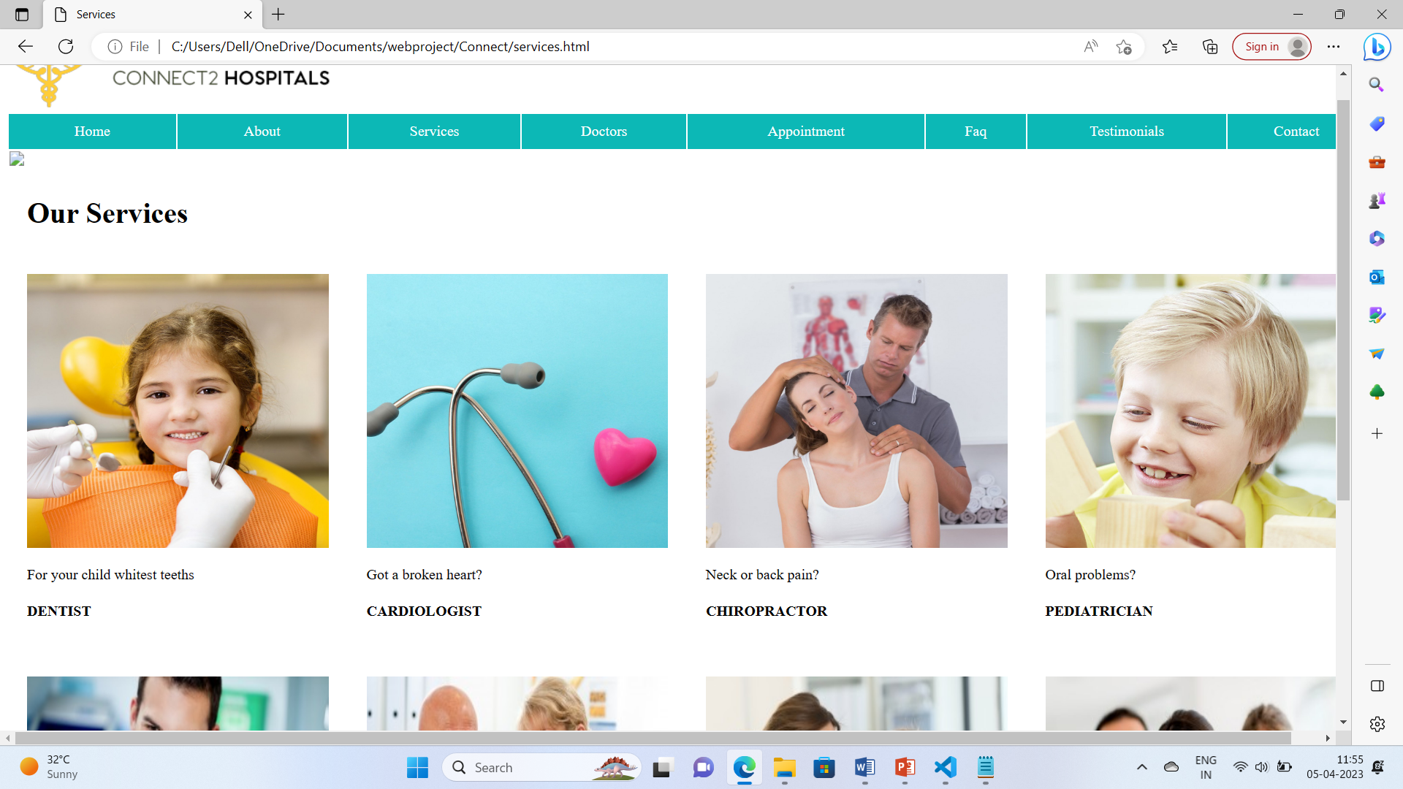

**Fig 6.3 Services Page**

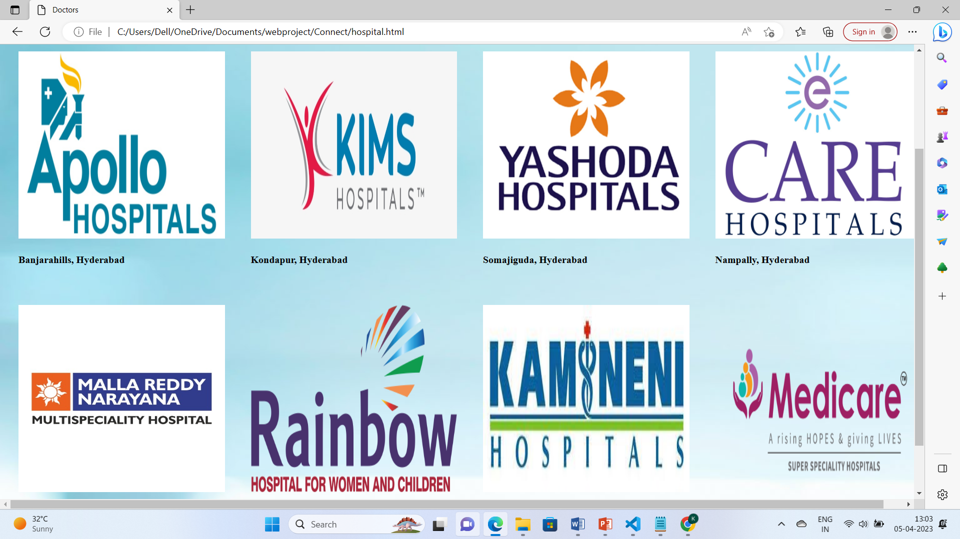

**Fig 6.4 Hospitals Page**

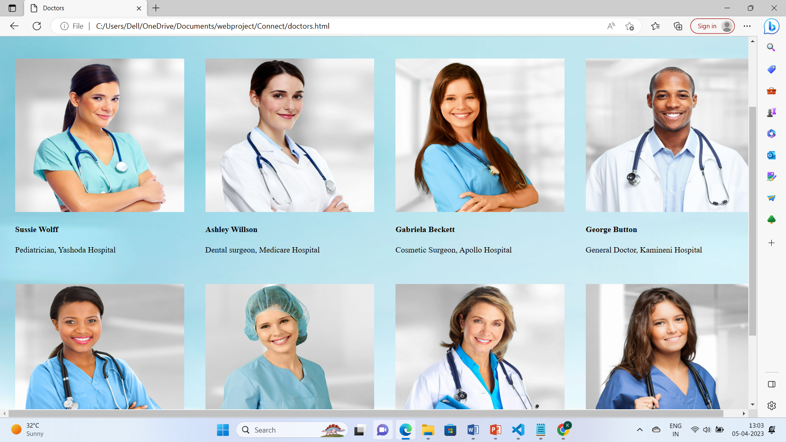

**Fig 6.5 Doctors Page**

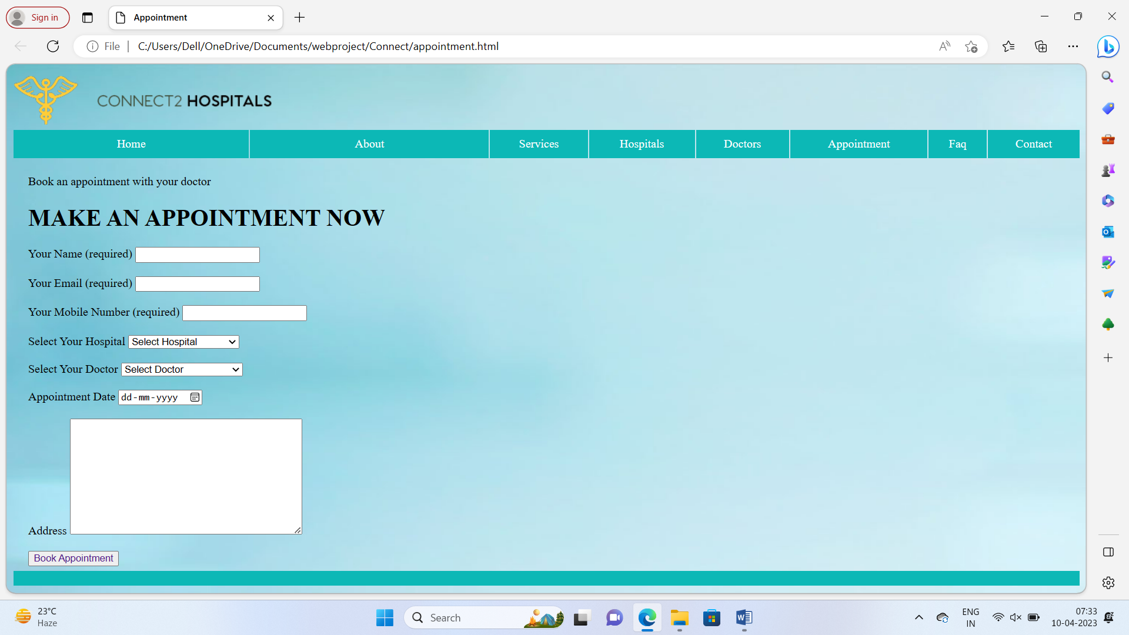

**Fig 6.6 Appointment Page**

**7. CONCLUSION**

The development of Connect2Hospitals involved many phases. The application helps in the total treatment of the patient who are independent and need treatment at their own locations. The patient need to have all the details of the hospitals and known about the doctors of that hospitals and their designation to get the right treatment. The main aim that the application need to reach every person to get their treatment done without any disturbances. WE have gained an insight into the working of the hospital that represents a typical real world situation. The software handles and secures patients’ information, prescriptions, diagnosis, and other hospital and patient-related data and digitally records them in its database. This website will help everyone to cure their problem at their location.

#### 

**8. FUTURE SCOPE**

The future of Connect2Hospitals Application will help in easy treatments and provide all the medications at the patient location and maintain a easy treatment environment in the world. The application will help each of the independent and emergency people to have treatment at the expected time and have the control of total health by the senior doctor and track your health by a well known doctor.